

WEB APP FOR EXPLICIT DATA GATHERING

IMPROving data gathering techniques for research purposes with modern UI App development techniques

Ammar Khan 17010020010

# Introduction

Researching and development have gone hand to hand in the industry where large sums of finances are involved, but in case of pure scientific researches, methodologies to gather data are mostly restricted to forms, google forms, or crappy websites with not-so-good looking User Interface that immediately and effectively works as a mosquito repellant work on mosquitos. This could be due to shorter teams dedicated to unearthing the facts to support their hypotheses, but to engage with human beings, we have to take care of methods to make data entry friendly to users. The user interface needs to be redefined and to be made more interactive so that users don’t get fed up and leave the research in the middle or maybe not even start to fillip data field.

# Problem Statement

Current solutions are rock solid in terms of research work, but they lack to incorporate progress made in UI. Let’s take a look at three major online research portals for Big 5 research.

<http://www.personal.psu.edu>

As you can see below. No background color, no text formatting. Too many details that most of the users have nothing to do. It looks like a webpage from the 90’s.

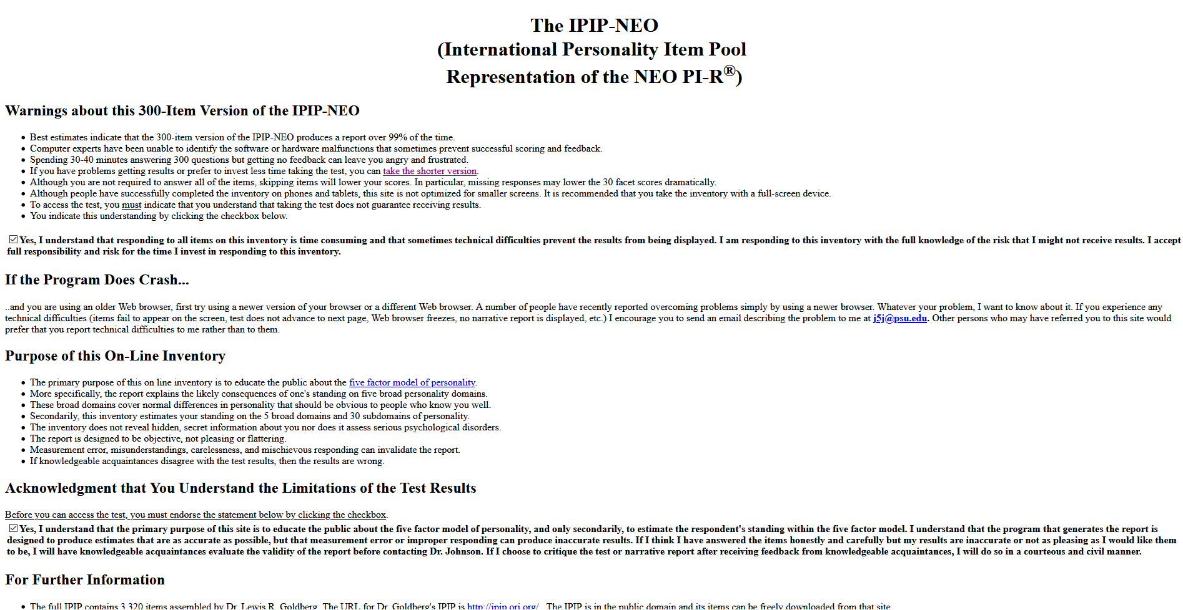

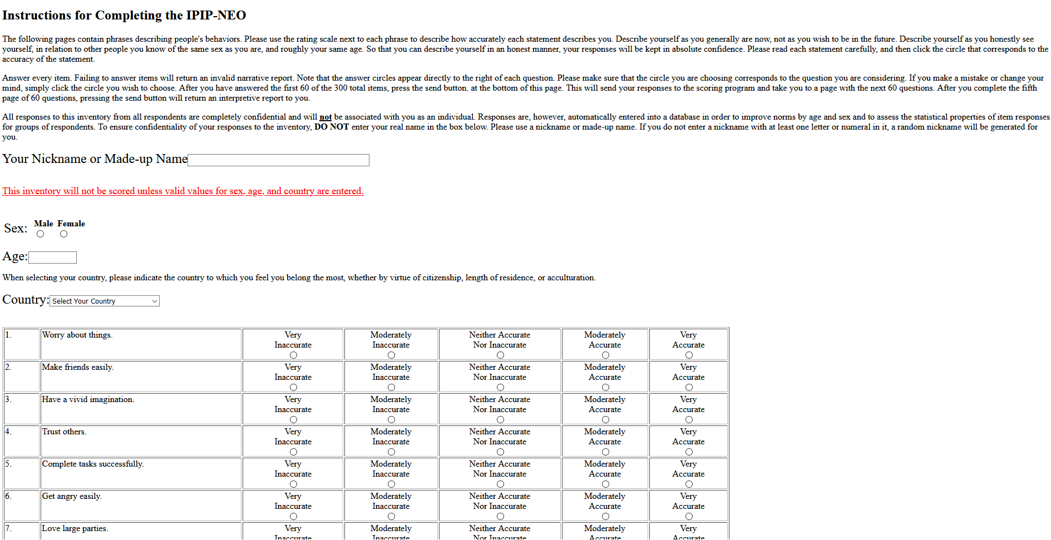

<https://openpsychometrics.org>

Poor background/foreground color selection. Poor font choice and most the important factor is that it looks to outdated.

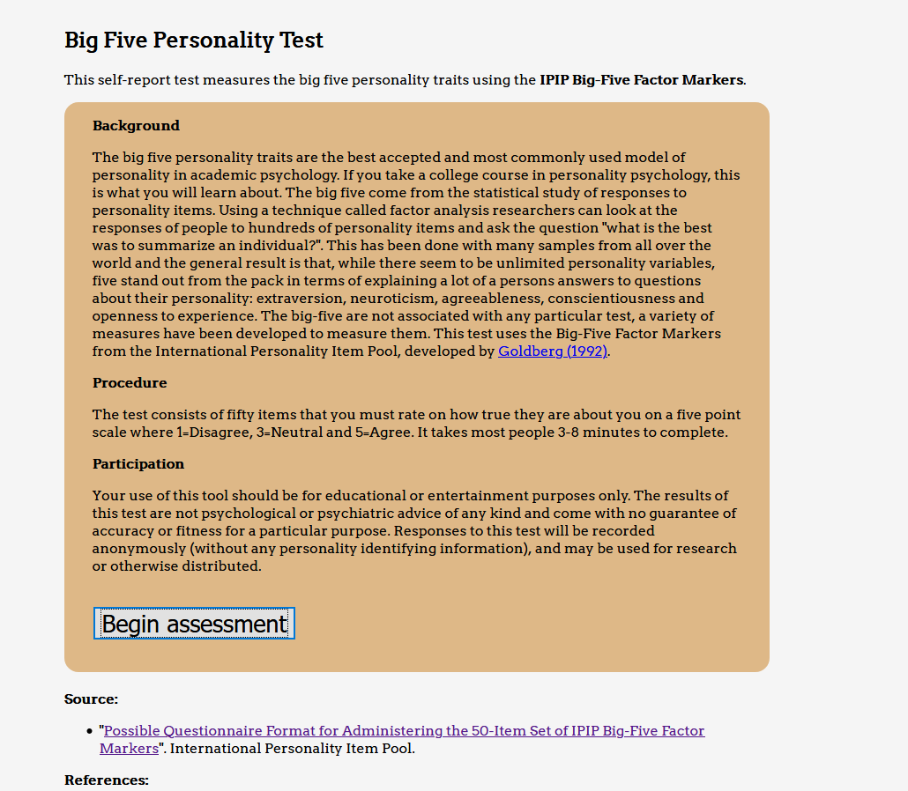

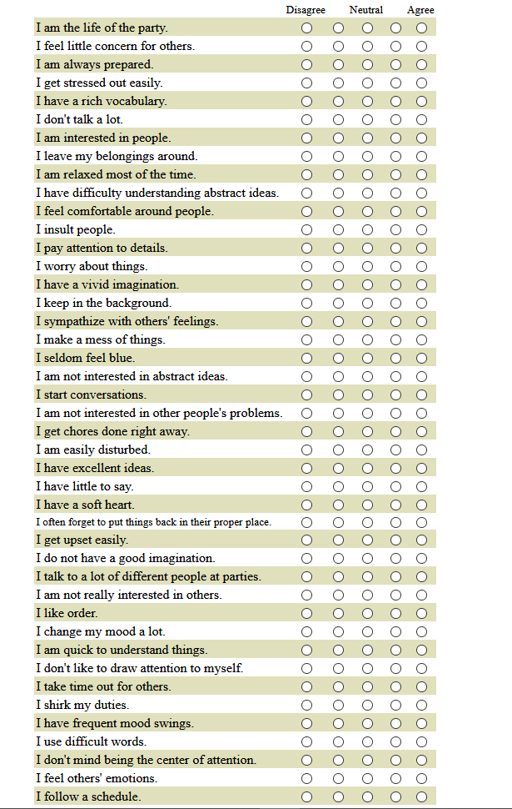

https://www.personalityassessor.com   
Comparatively better design with good background color choice and nice font selection. But, the latest app design follows trends for designs that resembles the pattern of an application for mobile. On the other hand, each question is shown once at a time and you have to click next each time for the next question.

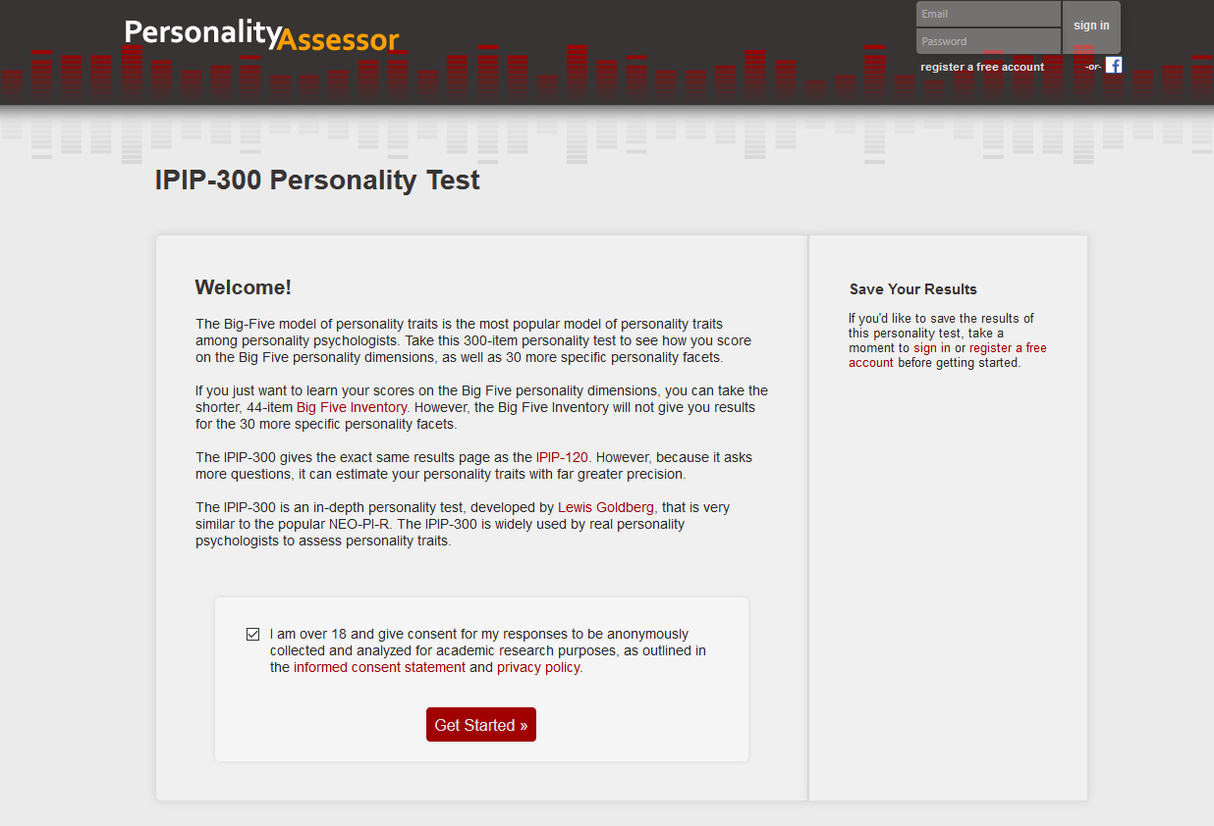

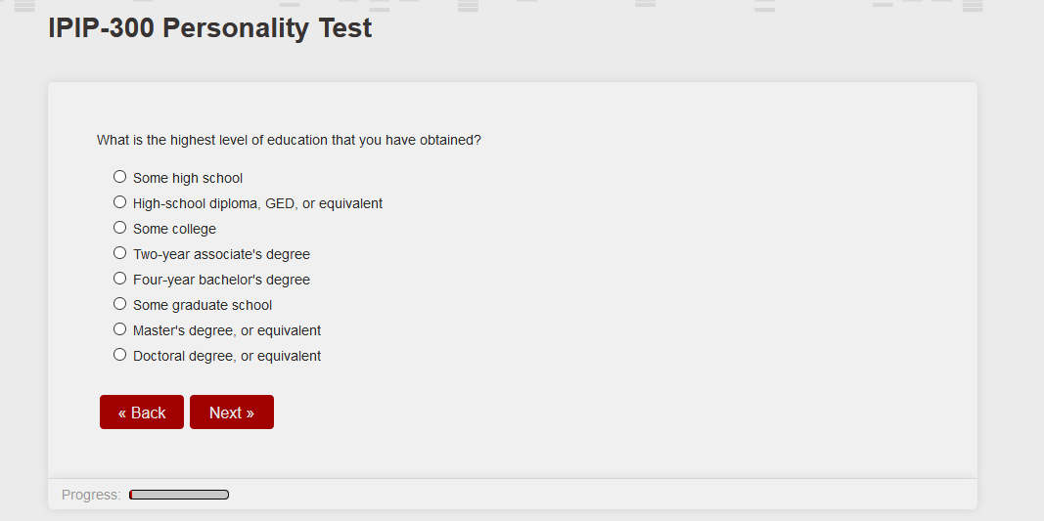

# Proposed Solution

The can enhance the design for these tests by using techniques in HCI to make data gathering more effective. Here is the list of advices:

* User interface needs to be of style that reflects the layout of mobile application. Since the advent of smart phones, most of the people are hung up to using that layout. So, there is an already built up muscle memory and familiarity with that design.
* The contrast ratio for background: foreground should be picked in a way that makes the words more visible and the background less eye-popping.
* We should put more focus on the research questions visibility instead of rest of the website’s details/annotations. Questions should be prioritized to catch user’s attention there. A user is not expected to be perform multiple tasks when solving the questions.
* In terms of interface, we have to groups similar details for user’s metadata in one page, but questions of similar type shall not be group as users then tends to race through the options which yields low quality research data.
* All extra stuff about detailed report for research shall be removed as a normal user is more curious about finding its personality type rather than going through methodology of research. If necessary, should be added in a separate page.

Proposed Design:

To solve the problem, I had to exhaust 3 different design patterns just to provide ease and maintain user attention during the long time of questionnaire filling and movie rating. For this to be benchmarked, users were given different storyboards and were asked to perform 4 tasks

* Login
* Signup
* Fill Questionnaire
* Rate movies